B.Tech. CSE (III YEAR - VI SEM) (2025-2026)

DEPARTMENT OF COMPUTER ENGINEERING &
APPLICATIONS

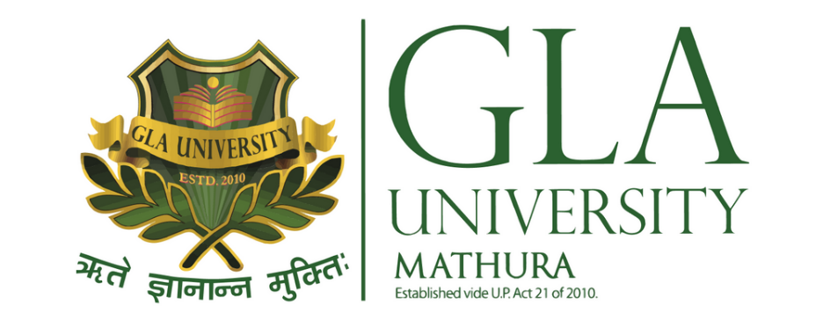
GLA University

17km Stone, NH-19, Mathura-Delhi Road P.O. Chaumuhan, Mathura -
281406 (Uttar Pradesh) India
Project Title: Migoo AI — Guidance, Simplified.
Team Member 1 : Keshav Agrawal UR : 2315800043

Team Member 2 : Parmeet Singh UR : 2315800059

Mentor Name: Dr. Ram Manohar Nisarg

Signature:

